Process and Procedure Names:  - Process: IT Management Operating System  - Procedure: HUE within IT Waterfall/Agile Projects | Work Instruction Name:  Stakeholder Mapping | Effective Date: 20-Mar-2017
Work Instruction Owner:  Tobias Komischke | Work Instruction Name:  Stakeholder Mapping | Revision Date: 08-Dec-2017

Purpose

Identify and prioritize those roles who have a stake in or are affected by the solution; document their key characteristics. HUE training is a prerequisite: Stakeholder Mapping Training.

Scope

This work instruction is for executing Stakeholder Mapping.

Work Instruction Activities

Step # | Description | Owner (Role) | Details (e.g. screenshots, charts, etc.)
 | Identify participants for the stakeholder mapping, e.g. project manager, SMEs, users | Project Manager
 | Invite participants to stakeholder mapping meeting. This meeting should be ideally face-to-face. If not possible, the next best solution would be a Skype call with screen sharing | Project Manager
 | In meeting, list all roles that are being impacted by the solution targeted in this project, i.e. those roles that are critical to the success of the project. Note that these stakeholders include users.  Sketch each different role as a silhouette.  For physical meetings, put each role and silhouette on post-it notes.  For Skype meetings, feel free to use the Bullseye Diagram Template. | HUE representative | Example:    Refer to the project type to personas matrix* below this table for a default set of standard stakeholder personas applicable for your project type.
 | Move the roles onto a bulls-eye diagramm:  - Draw 3 concetric circles.  - Label the circles primary, secondary and tertiary with primary representing the inner most circle.  - Place the roles on the bulls-eye in order of criticality to success  - Make sure that only a limited number of roles are placed in the center | HUE representative | 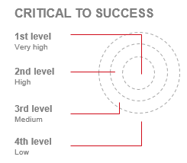  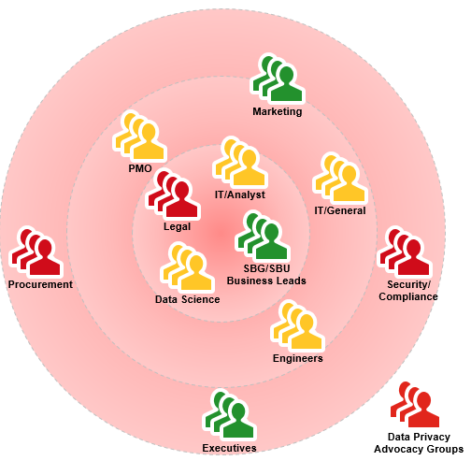  Refer to the project type to personas matrix* below this table for default levels that stakeholders are getting impacted by your project type.
 | Color-code the roles on the bulls-eye according to the level of knowledge the project team has about them:  - Red = low level of knowledge  - Yellow = medium level of knowledge  - Green = high level of knowledge | HUE representative | 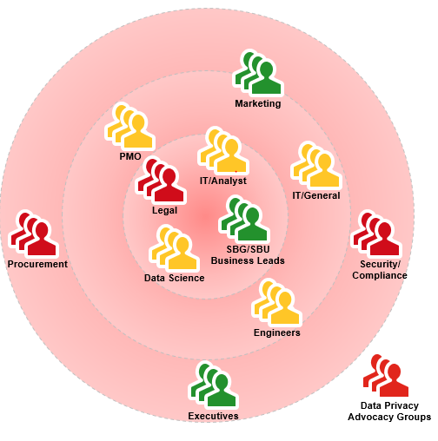
 | Review and interpret the stakeholder map with the project team:  Roles in the center that are shown in red are those that need to be engaged with with higher priority than roles that are either green and/or in the periphery of the bulls-eye. The goal is to understand each critical role’s characteristics, needs and expectations. | HUE representative | Work Instructions for research:  - “Interviews” and/or  - “Field Observations” and/or  - “Surveys”
 | If applicable, transfer the stakeholder map into an electronic version using, e.g. Powerpoint | HUE representative
 | Store electronic stakeholder map as project artefact on project share drive | HUE representative

*Project type to Personas Matrix
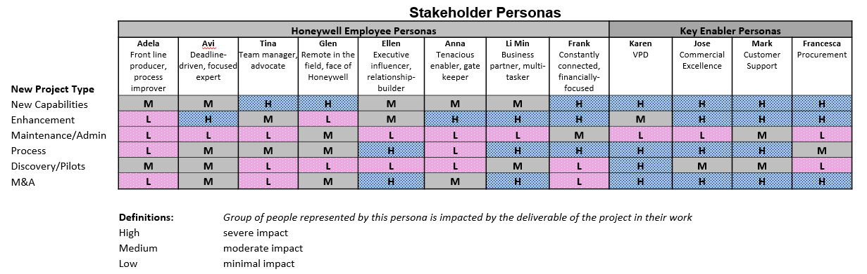

For details on the personas, refer to these links:

- The 8 HON Employee personas  - Anna – Assistant  - Tina – Team Manager  - Ellen – Executive  - Avi – Engineer  - Li Min – Human Resources  - Frank – Finance/Procurement  - Adela – Front Line Worker  - Glen - Remote Worker | - The 4 Key Enabler personas  - Karen – VPD  - Jose – Commercial Excellence  - Mark – Customer Support  - Francesca - Procurement

Enforcement

Failure to adhere to published policies, processes, procedures, work instructions and standards will be evaluated on a case by case basis and may result in disciplinary action. Published policies, processes, procedures, work instructions and standards are also subject to audit by Honeywell Corporate Audit and external auditors for verification of compliance.

Version Control and Review Frequency

This Procedure is to be reviewed at minimum annually.

Date Last Reviewed: 08-Dec-2017
Reviewed By: Tobias Komischke, IT HUE Leader

Version # | Effective Date | Section(s) | Description | Author | Content/SME  Approval | Work Instruction Owner Approval
1.0 | 20-Mar-2017 | Full document | First version | Tobias Komischke | Madhumita Gupta | Tobias Komischke
1.1 | 25-Aug-2017 | “Work Instruction Activities” Section | Incoroporated reference to Project Types | Tobias Komischke | Madhumita Gupta | Tobias Komischke
2.0 | 01-Nov-2017 | All | Incorporated new role of HUE representative and aligned to approved HUE process integration with waterfall/agile Software process | Madhumita Gupta | Tobias Komischke | Tobias Komischke
2.1 | 08-Dec-2017 | All | Formatting edits based on Process Change Register requests | Tobias Komischke | Madhumita Gupta | Tobias Komischke
*Process Owner, Process Governance and External Compliance approvals are through the automated tool

